Input Sumary of Income:

1. User Select specify the Employee
2. User Select the Summary of Income tab, and fill the other information such as currency code, date, and amount

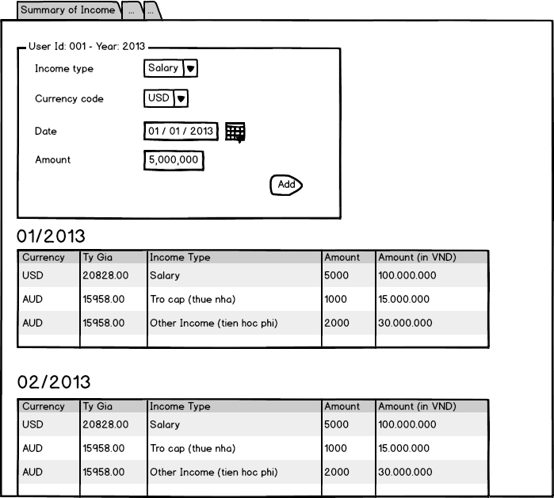

1. User click on ADD
2. The system will show the information of income as table.